Unit 3: Lesson 17
Managing Our Actions

Goal: To learn that the social and emotional positive action of managing our actions helps us feel good about ourselves.

STORY:
It wasn’t a big fight, just a couple of boys scuffling in the schoolyard. But others were starting to take sides, and Chung knew that the fight could get bigger. It had happened before; he was worried – and scared.
So, he went to talk to Mrs. Jackson, his teacher, a woman almost six feet tall with a booming voice. She told stories to get a point across and wore African clothes with vibrant patterns of red and gold. There wasn’t a quiet thing about her.
“Mrs. Jackson, can you get the guys to talk to one another instead of fighting?” Chung asked. “When they fight, I get scared.”
“Sure. As soon as class starts, we’ll talk, and you can help,” said Mrs. Jackson.
As soon as everyone was seated, Mrs. Jackson started. “You are friends,” she said. “Now, why are you fighting?”
As she walked toward the back of the room, she paused. “Othello, why were you fighting?”
“I’ve got my pride. Nobody’s going to tell me what to do,” he replied.
“Jamie? Were you fighting, too?”
“Yeah.” It didn’t pay to lie to Mrs. Jackson
“Why?” Mrs. Jackson demanded.
“I’m not going to get pushed around in front of everybody.”
“Chung, were you there?” Mrs. Jackson motioned to him as she continued speaking.
“Yes,” Chung replied. “I was watching.” Then looking at his friends, he blurted out, “I hate it when my friends fight each other. Anybody can swing fists. It’s an easy thing to do. It takes more guts to get along and not fight.”
The boys sat in silence, squirming, but obviously thinking about what Chung has said. After what seemed like a long time, Mrs. Jackson began talking. She helped them realize that they all wanted dignity. They wanted to be treated with respect and to be treated fairly. After that, the boys worked toward understanding one another. There were fewer fights, and they felt good about themselves. It was a positive action for Chung to speak out.
Take another look at the name of this program: It isn’t called Positive Thought or Positive Feeling. It’s called Positive Action, because it’s the actions – the actual doing – that helps us feel good about ourselves. When we manage our actions in positive ways, a positive self-concept is the result.
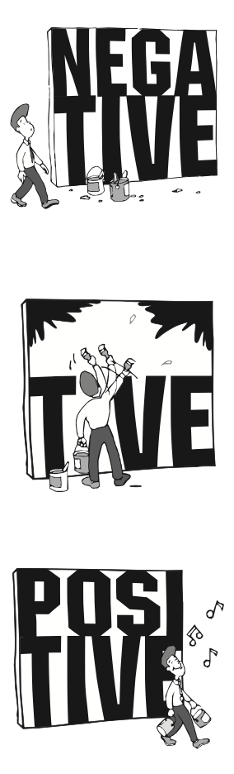
Managing our actions is a positive action that helps us feel good about ourselves. Our actions are important to us because they directly determine how we feel about ourselves. In order to feel good about ourselves, we must manage our actions in positive ways.
Of course, we all want to feel good about ourselves, but we feel good about ourselves only when we take positive actions. Therefore, we must manage our actions, so they become more positive. We manage our actions by thinking about their effects on us and others before we do them. We think them through to their consequences. If the consequences will help us feel good about ourselves, then we know its okay to do the action. But if the consequences would leave us feeling negative, then we know we should choose another thought to act upon.
Unfortunately, sometimes we find ourselves doing negative actions because they are easier to do in the short run. But their ease is deceptive. They cause us problems in the end. When we do something negative, we have to do more to get ourselves out of trouble than if we had done a positive action in the first place. Even though positive actions require more thinking and effort in the beginning, they pay off in the long run.
Acting positively is an issue of self-discipline. By knowing physical, intellectual, social, and emotional positive actions, we can teach ourselves to act positively without having to give each action a great deal of thought. In fact, our goal is to know positive actions, so they become a natural way for us to act.
Our actions are also important because they have an effect on others. When we act positively, others feel comfortable and are able to act in similar ways. When we act positively, we feel good about ourselves and build our own self-concepts. By being the best we can be, we also give our best to others. What we do matters – to ourselves, to our families, to our friends, and to our communities.
The key to managing actions is simple: think positive thoughts and choose to act from those thoughts. Doing positive actions is the real key to feeling good about yourself, and having a good self-concept makes us successful and happy. So, let’s choose a course of action – the course of managing our actions.
QUESTIONS:
- Why should we manage our actions?
- How do our thoughts influence our actions?
- How can we choose positive actions?
- What is meant by the “consequence of an action”?
- How can we know whether or not to do a certain action?
- How does managing our actions affect self-concept?
- How do you manage your actions?
- How do you feel about yourself when you act positively?
- In what area of your life would you like to act more positively?
Pay particular attention to your actions this week. Select an area of your life in which to begin managing your actions.
Before taking any action in this area, stop and think the action all the way through to its effect on you and others. Determine how the result of this action will make you feel about yourself. If you will feel good about yourself, then go ahead and do the action. If not, then select another action and consider what will happen in your life.
As many times as you can this week, repeat this process of choosing a positive idea, determining the consequence if you can, and then doing the positive action you choose. At the end of the week, look at that area of your life and consider the effect managing your actions made. Now that you have a pattern, begin to manage your actions in other areas of your life, also.
FAMILY POSITIVE ACTIONS
QUESTIONS:
- Why is it important for us to manage our actions?
- What actions could we manage more positively to improv our family life?
- How do we feel about our family when we act positively toward one another?
- How can we help one another choose positive actions?

Let’s do a special exercise to practice the positive action of managing our actions.
Let’s start by writing each person’s name on a slip of paper and put the slips in a hat. Each of us will draw a name out of the hat and keep the name secret. The person whose name you’ve drawn will be the focus of your positive action.
Do at least one positive action that will make a difference for that person. Some possibilities might be to help with a project, share a special time together, offer to help with homework, or tuck a surprise in his or her coat pocket or somewhere else where he or she will find it. Let’s do our positive actions in such a way that no one can guess whose name we drew.
parent positive actions
Ask Yourself: How do you decide what you are going to do? What kind of actions do you take toward your family when you feel good about yourself? When you don’t feel good about yourself? Do the actions you take toward your family make you feel good about yourself as a parent? if not, what changes would you like to make? How can you encourage you children to manage their actions?
Plan and Do: Think about what your children are learning from your actions. Select an area in which you would like to be a better role model. Think of specific positive actions that would be significant to your children. Pick one or two and try to do them consistently this week. Pay attention to your feelings about yourself and to how your children respond to your actions. Reinforce your children’s positive actions this week with encouraging words.

COMMUNITY POSITIVE ACTIONS
Let’s manage our community actions this week by doing positive actions for someone in our neighborhood. W can do something together, or we can each do something on our own. We might want to take a dessert to a neighbor or offer to help someone wash windows. We could help out at a food kitchen or take clothing we no longer use to a homeless shelter. Let’s also reinforce the positive actions we see in our community. For instance, we could compliment a helpful store clerk and show appreciation for other positive things that go on in our neighborhood. As we do these positive actions, let’s pay attention to the good feelings we get about ourselves.

SUMMARY
Chung was managing his actions. He chose to take a positive action by talking to his teacher. He could have run away from the fight. It certainly would have been easier than saying what he said to his friends. Chung had thought the situation through to its consequences. He chose a positive thought and took a corresponding action. His positive actions of telling his teacher and then his friends how he felt about the fighting made him feel good about himself.
We all want to feel good about who we are, what we are doing, and how we treat others. In order to have a positive self-concept we, too, must manage our actions by thinking them through to their consequences. It takes time and effort. It frequently appears easier to do negative actions, and generally it is – in the short run. But negative actions have a way of causing us more trouble in the long run. They also keep us from getting the results that we want.
When we take the time and effort to do positive actions, we save ourselves the trouble of undoing the results of the negative actions somewhere down the road. Doing positive actions in the first place saves us time and other resources. Positive actions result in feeling good about ourselves. By doing positive actions and eliminating as many negative ones as we can, we find that we really do feel good about who we are, what we are doing, and how we treat others – we are successful and happy!

Word of the Week: Actions
What you do or cause to happen.

